UNIVERSITY OF PETROLEUM AND ENERGY STUDIES


Student Name: Deepanshi Shukla
Sap ID: - 590021964
Batch: B10
Course: B. Tech (CSE)
SUBJECT: python Programming lab
Experiment: 1
Submitted to:
Kamakshi Rautela

Python Programming Laboratory
Experiments 1
Experiment 1: Python Installation and Basic Python Statements
  - Aim
To understand Python installation, basic syntax, variables, operators, and simple programs.
  - Theory
Python is a high-level, interpreted programming language. It supports interactive and scripting modes and is widely used in software development, data science, and automation.
  - Programs

1.Install Python and write the steps of installation and understand difference between scripting and interactive modes in IDLE.
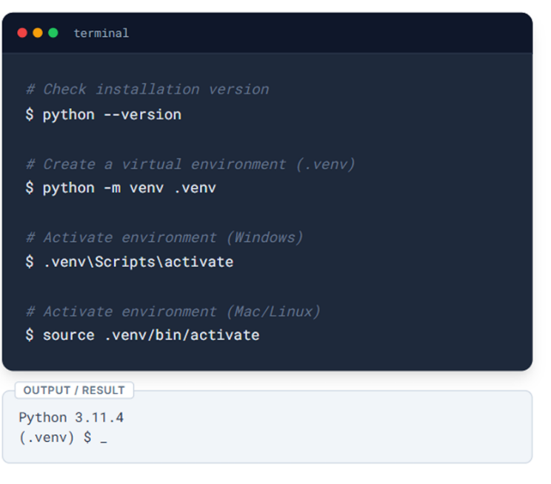

2. Print Age and Its Data Type
Code:
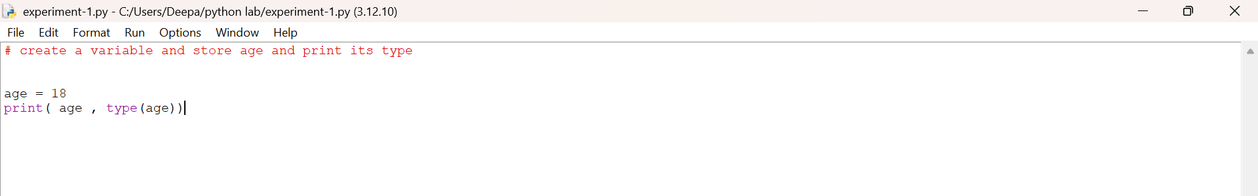
Output:
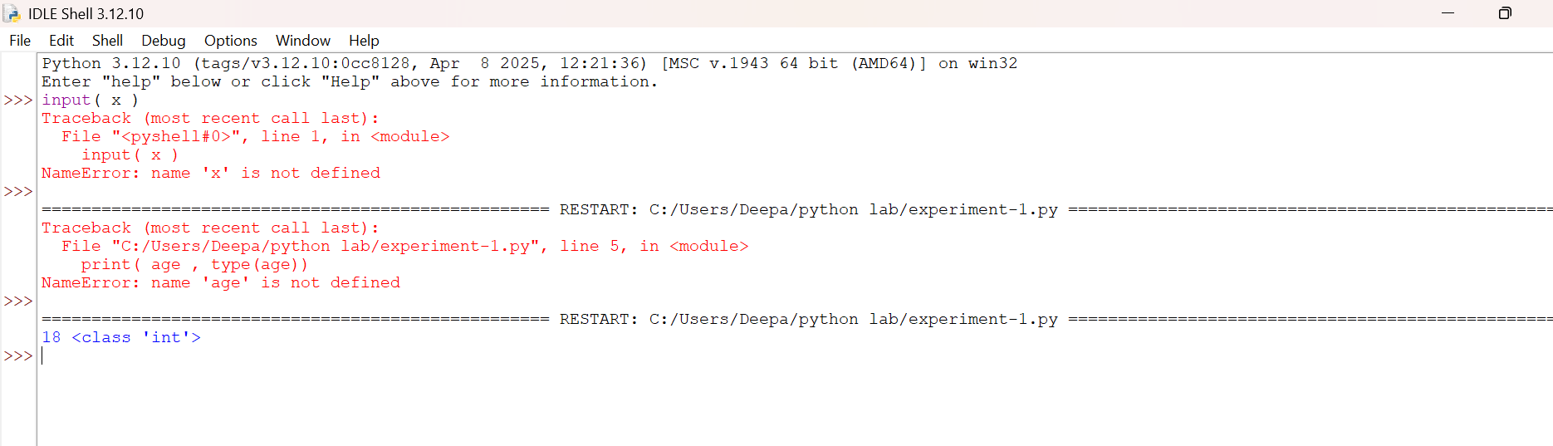

3. String Variable
Code:
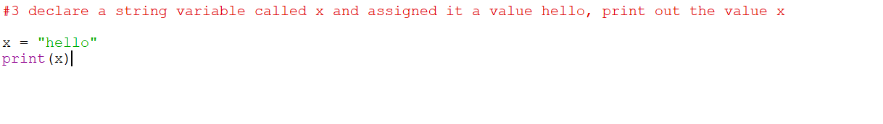
Output:
4. Printing Different Data Types
Code:
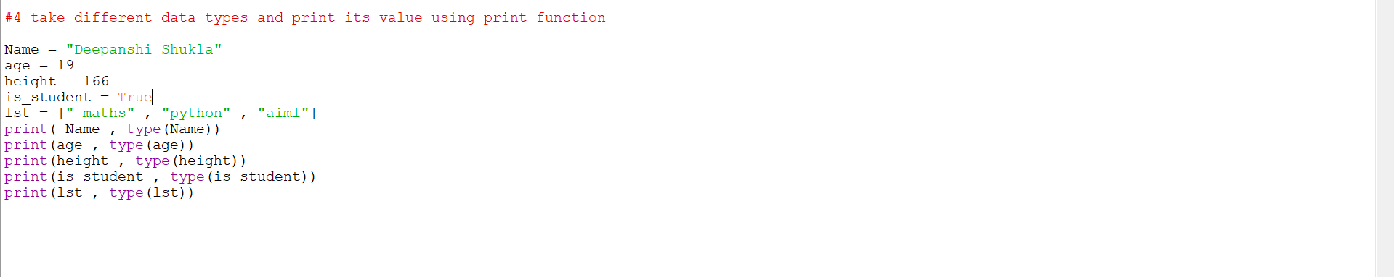
Output:
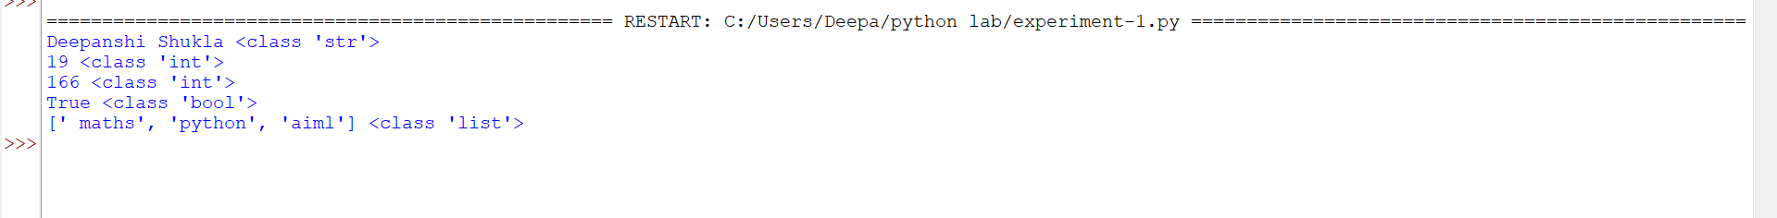

5. Arithmetic Operations
Code:
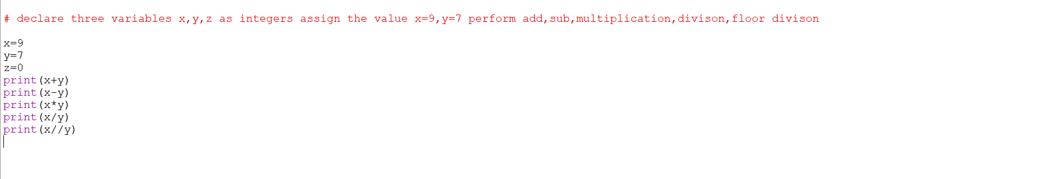
Output: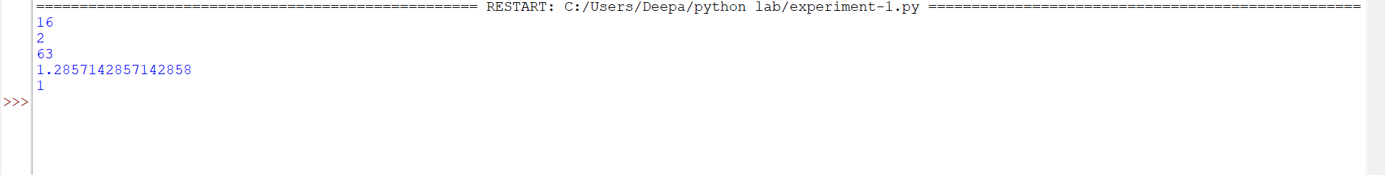

6. Hypotenuse Using Pythagoras Theorem
Code:
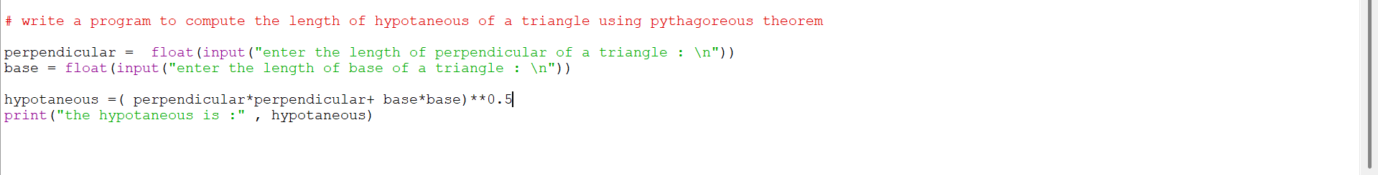
Output:
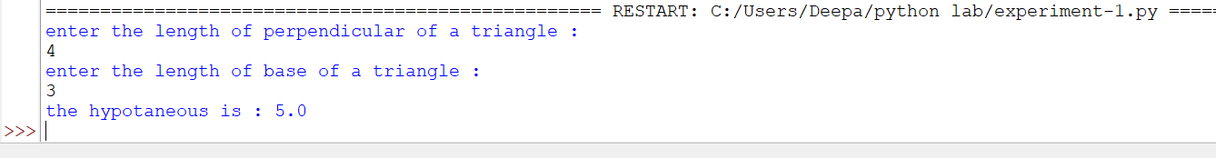

7. Simple Interest
Code:
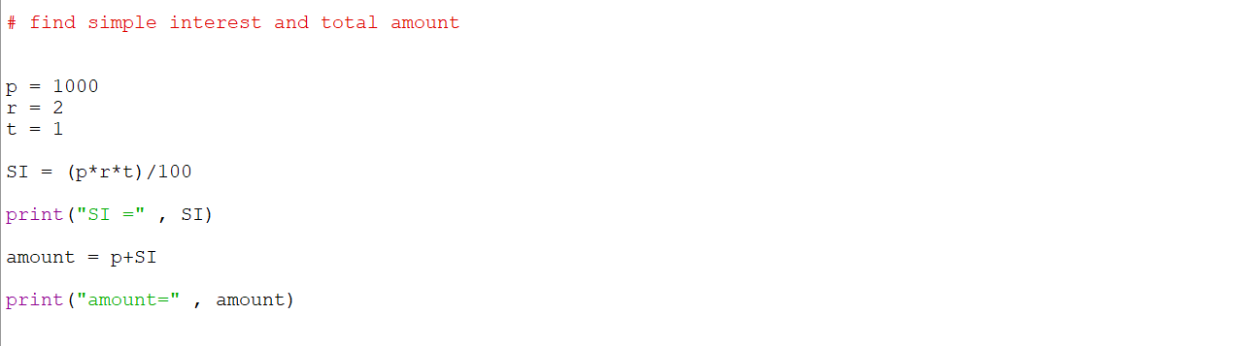
Output:
8. Area of Triangle
Code:
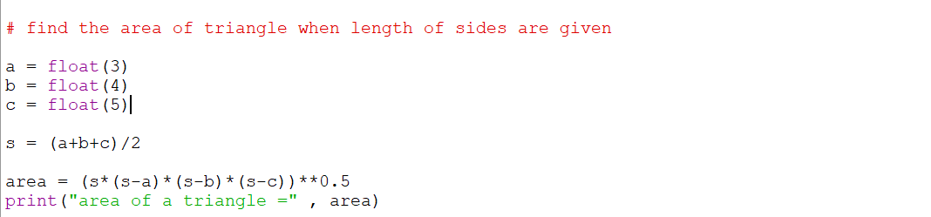
Output:

9. Convert Seconds
Code:
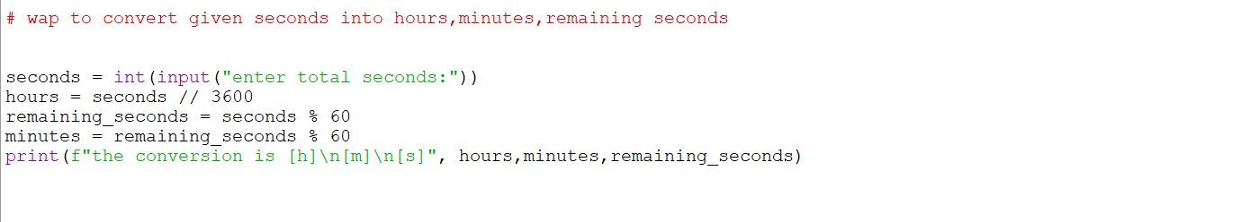
Output:
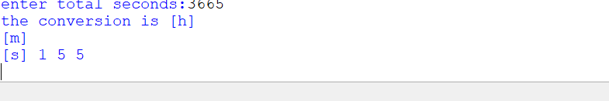
10. Swap Two Numbers
Code:
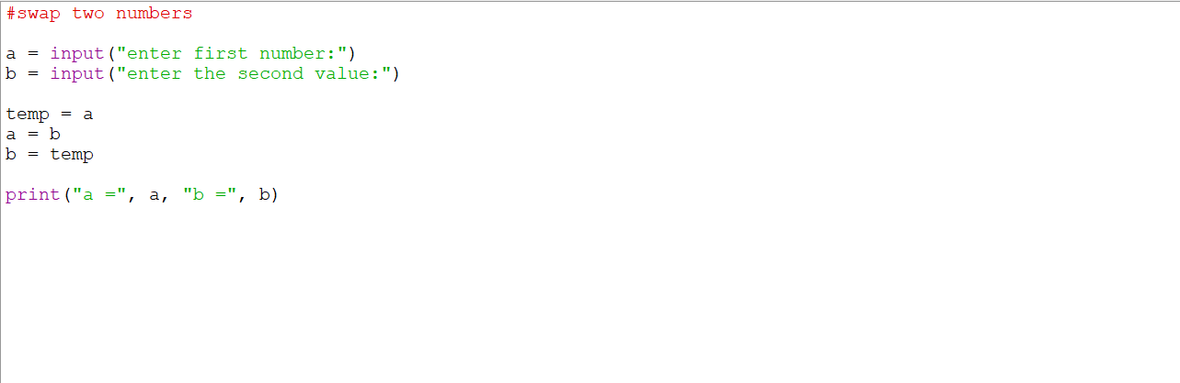
Output:

11. Sum of First n Natural Numbers
Code:
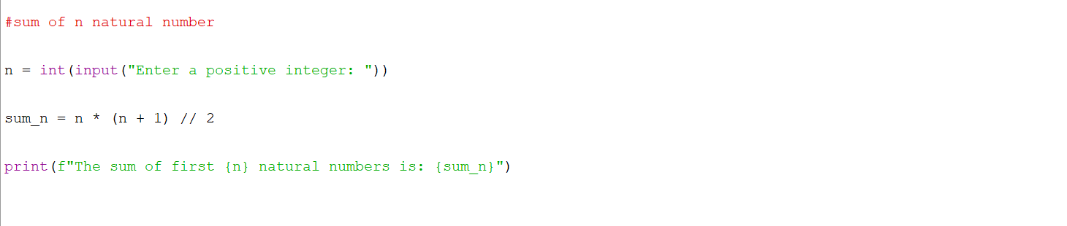
Output:

12. Bitwise Operators
Code:
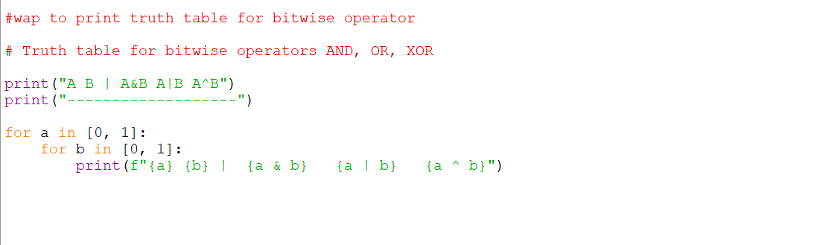
Output:
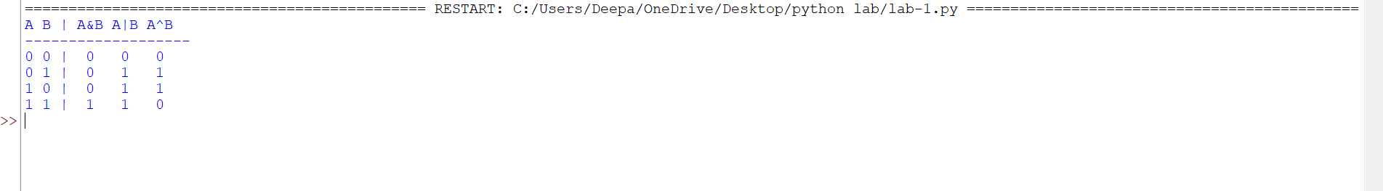

13. Shift Operators
Code:
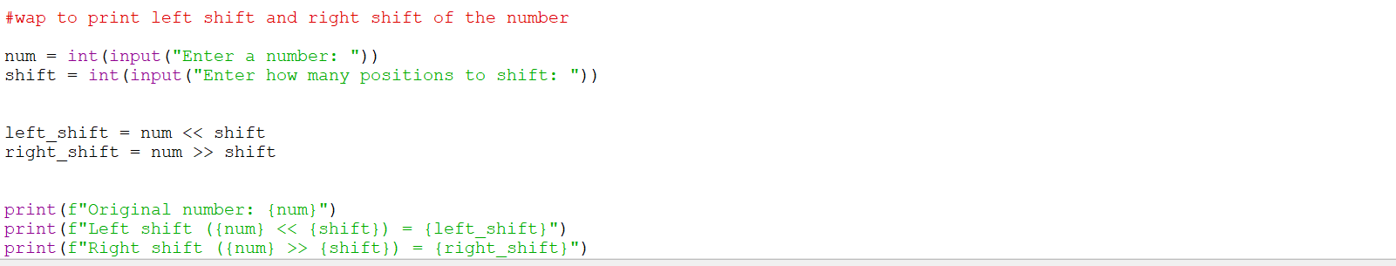
Output:
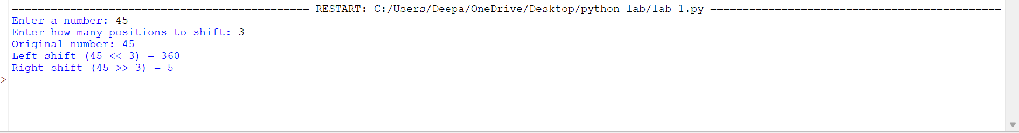
14. Membership Operator
Code:
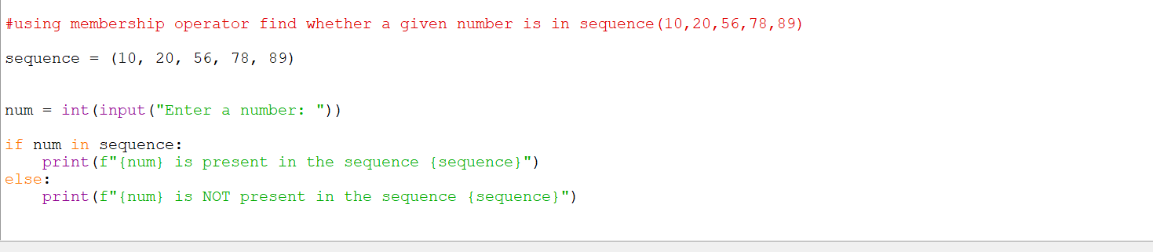
Output:

OBSERVATION
- Learned the use of bitwise and shift operator
- Learned about math.h
- Use of arithmetic operators
- Got basic introduction of python coding

